Entering Data Using the DL Editor

Important Note: This document is meant to be used in tandem with an Excel file called Data Entry Examples.xlsx, which contains the raw data used in all of the examples in this document.

UCINET uses a matrix metaphor for thinking about all data. But this doesn’t mean that your own data need to be in matrix format. UCINET accepts a wide variety of formats. This tutorial covers the most commonly used ones.

The best way to get the data into UCINET is via the DL Editor. The DL Editor is basically a simple spreadsheet. You can type data directly into the DL Editor, but frankly we recommend using Excel instead. Excel is more powerful and flexible, and you probably already know how to use it. More importantly, the DL Editor has no way of making incremental saves as you go along. So in this tutorial, we will take data from Excel and cut and paste it into the DL Editor.

The DL Editor can be started by pressing the DL Editor button on the UCINET main toolbar, as shown in Figure 1.

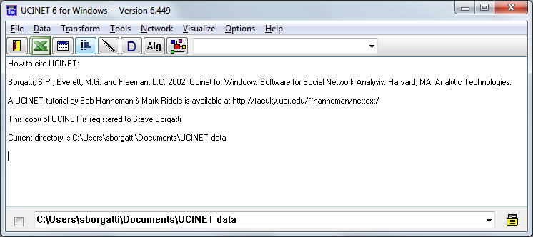
Display Button
DL Editor
Figure 1. UCINET main screen.

Matrix Format – Network data

The matrix format is probably the simplest conceptually and is good for very dense datasets, where there is a value between pretty much every pair of nodes.

Step 1. Start up the DL Editor by pressing the button on the UCINET toolbar. Clear the DL Editor by pressing the New button at the far left.

Step 2. Cut and paste the matrix in the TimeSpent tab of the accompanying Excel file (Data Entry Examples.xlsx) into the DL Editor. Choose “full matrix” as the data format, and make sure col headings and row headings are checked. These indicate that the first row and first column are intended to be taken as node labels rather than relational data.

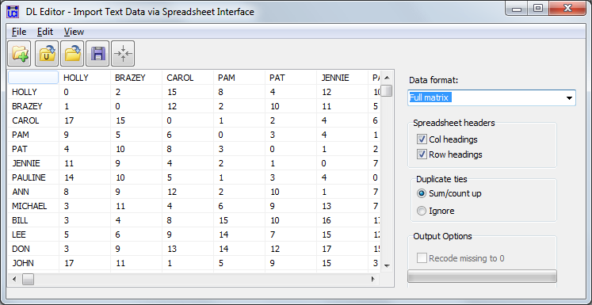
Save button
New button
Figure 2. DL Editor showing matrix

Step 3. Press the Save button and choose a filename, such as TimeSpent. This converts the data to a UCINET system file (which consists of two physical files, TimeSpent.##h and TimeSpent.##d).

Step 4. Close the DL Editor and choose the Display button (see Figure 1). The result should be the output shown in Figure 3.
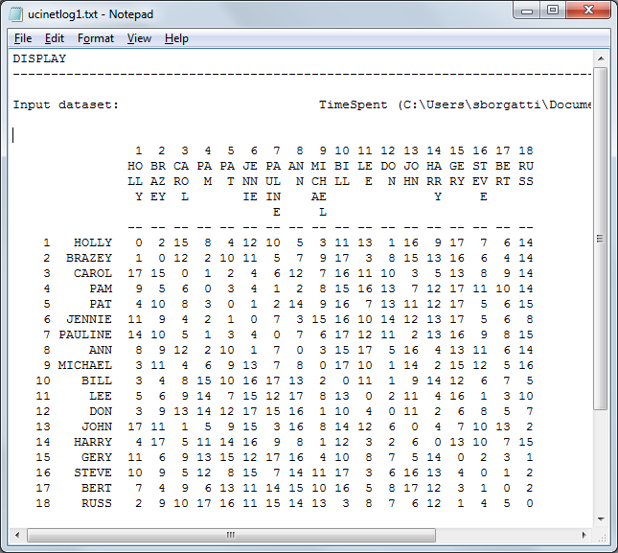
Figure 3. Output from Display.

Matrix Format – Attribute Data

Attribute data are matrices in which the rows are nodes and the columns are variables representing attributes of the nodes. For example, the variables might race, gender, and socio-economic status.

Step 1. Clear the DL Editor by pressing New button. Cut and paste the Attributes Tab of the Excel file into the DL Editor.

Step 2. Set the format to ‘full matrix’ and ensure that col headings and row headings are checked.

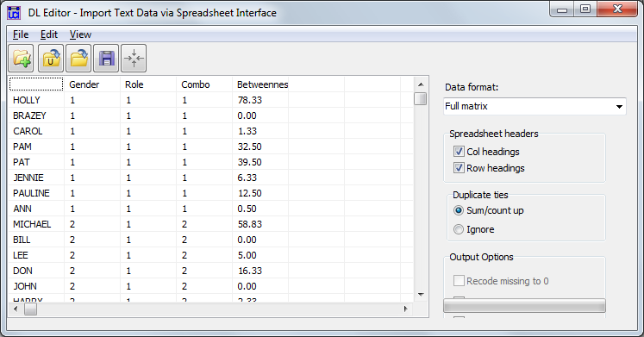
Figure 4. DL Editor showing attribute data in matrix format.

Step 3. Press the Save button and save as dataset Attributes.

Step 4. Confirm success by pressing the Display button in UCINET’s main menu and selecting the ‘attributes’ dataset.

Nodelist1 Format

The nodelist1 format is used for 1-mode network data (i.e., the data represent ties among a single set of nodes) where the data record the presence of ties but not the strength. This is an extremely economical format.

Step 1. Clear the DL Editor by pressing New button. Cut and paste the data in the Karate tab of the Examples Excel file into the DL Editor. Figure 5 shows the result. Note that in these data the nodes are represented only numbers. This is a feature of this particular dataset, not a requirement of the Nodelist1 format.

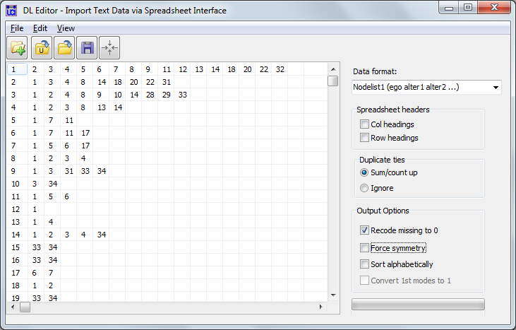
Figure 5. DL Editor showing nodelist1 format. In this example, the nodes are identified by number.

Step 2. Select Nodelist1 as the data format.

Step 3. Press the Save button and save as dataset Karate. Check results by using UCINET’s Display function, as we did in the matrix examples.

Note that if the data are undirected (or all ties reciprocated) you can make data entry even more efficient by (a) checking the Force Symmetry box, and (b) entering each tie only once. An easy way to do this is to only enter node numbers that are larger than the node number of the sender. For example, with Force Symmetry turned on, the following two datasets are identical:

Force Symmetry box checked | Force Symmetry box unchecked
1 2 3 4 5  2 3 5  3 4  4  5 | 1 2 3 4 5  2 1 3 5  3 1 2 4  4 1 3  5 1 2

The same trick can be applied with nodes identified using names by only including ties to nodes that are further along on the alphabet. This ensures that once the tie from Abe to Zoe is included, you won’t need to include a tie from Zoe to Abe. Figure 6 shows the Karate data entered with Force Symmetry on.
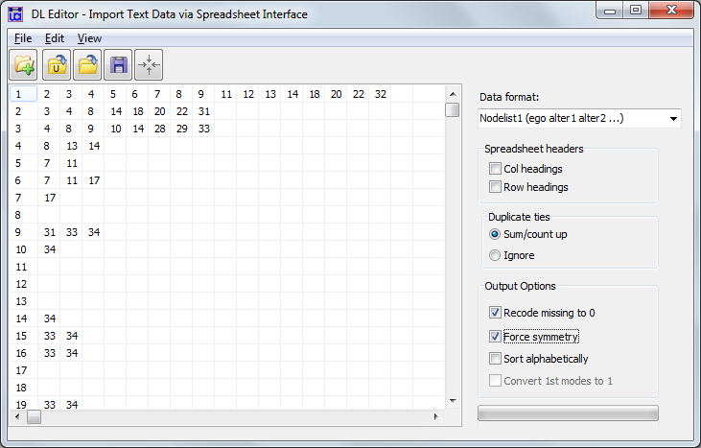
Figure 6. Karate data with Force Symmetry checked on and the data entered more economically.

Nodelist2 Format

The nodelist2 format is used for 2-mode network data where the data represent membership or affiliation ties such as attendance at events or membership in clubs. A key aspect of 2-mode network data is that there are two kinds of entities (e.g., persons and organizations) and ties always link one kind of entity with the other kind of entity. Hence in a person by organization dataset, there are no (direct) ties between persons and no ties between organizations. This is an extremely economical format, but can only be used to represent the existence of ties – no strength of ties are permitted.

Step 1. Clear the DL Editor by pressing New button. Cut and paste the data from the WomenEvents tab in the Excel file into the DL Editor. Figure 6 shows the result.

Note: the “Force Symmetry” checkbox is ignored in this format.

Step 2. Select Nodelist2 as the data format.

Step 3. Press the Save button and save as dataset WomenEvents. Check results by using UCINET’s Display function, as we did in the matrix examples.

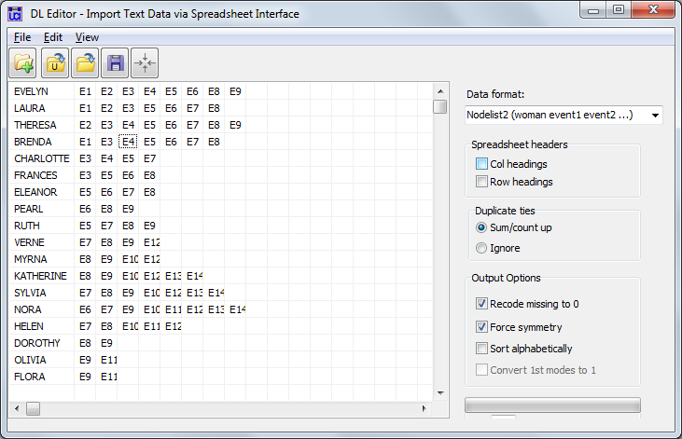

Edgelist1 Format

The edgelist1 format is used for 1-mode network data in which the data represent ties among a single set of nodes. Both binary and valued data can be represented in this format. The format consists of listing pairs of nodes on a line, indicating that there is a tie between them (from the first node to the second node). When the data are valued, there is a third field that is used to enter the strength of the tie. If omitted, the tie strength is assumed to be 1.

Step 1. Clear the DL Editor by pressing New button. Cut and paste the data in the Monks Edgelist1 tab of the Excel file into the DL Editor. Figure 7 shows the result. Note that in this case there is a third column containing values. This is only needed for valued data. When the data are dichotomous, you can just use the two columns given the sender and received nodes.
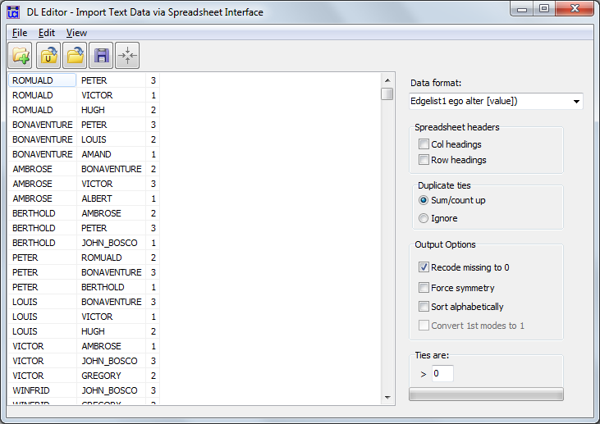
Figure 7. DL Editor showing edgelist1 format. In this example, the data are strengths of tie, so there is a third column used to enter the tie strength,

Step 2. Select Edgelist1 as the data format.

Step 3. Press the Save button and save as dataset Karate. Check results by using UCINET’s Display function, as we did in the matrix examples.

